Experiment – 2

Create a simple cloud software application for Flight Reservation System using any Cloud Service Provider to demonstrate SaaS.
AIM:
To design and implement a Flight Reservation System as a cloud-based SaaS application using Zoho Creator.
PROCEDURE:
1.Begin by signing in to Zoho Creator with a valid account and initiate the development process by creating a new application from scratch, allowing full control over the structure and design of the system.
2.Develop a Flight Details form to systematically record essential flight information, including source location, destination, departure or arrival time, and ticket fare, ensuring accurate storage and easy retrieval of flight data.
3.Create a Passenger Details form to capture and maintain important personal information of travelers, such as their name, contact details, and other relevant identification data required for booking.
4.Design a Reservation or Booking Details form and incorporate lookup fields to establish a relational connection between passengers and available flights, enabling efficient management of bookings within the application.
5.Configure fundamental workflows and automation rules within the application to automatically update the booking status, thereby reducing manual intervention and improving operational efficiency.
6.Publish the completed application and activate cloud access so that users can securely access and interact with the system online through a web browser.
7.Upon completing these configurations and deployment steps, the cloud-based flight reservation software is successfully developed and made available for use.

IMPLEMENTATION:
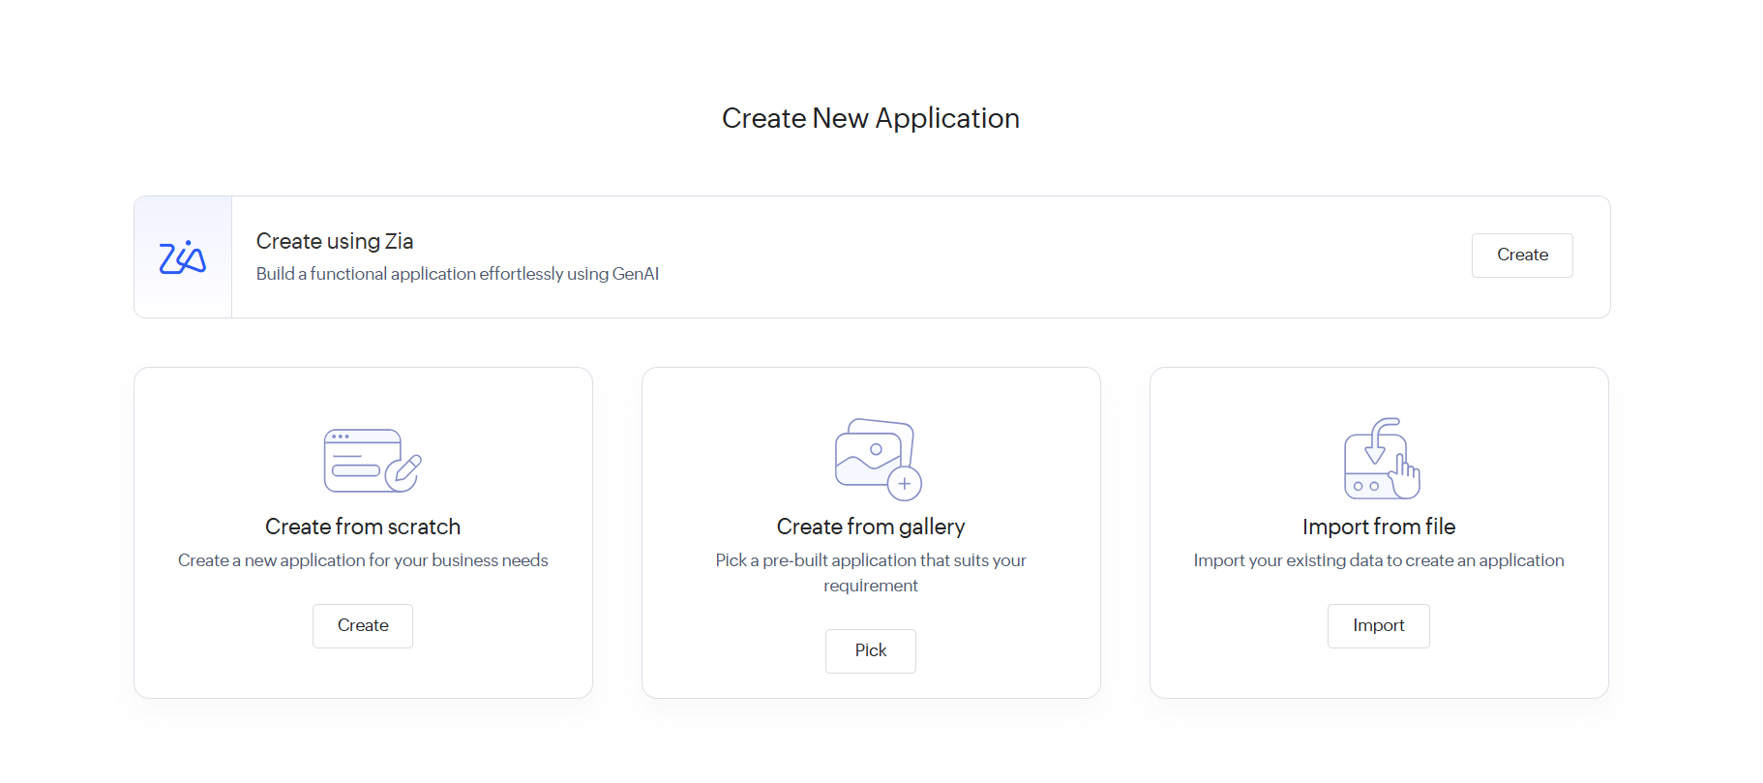
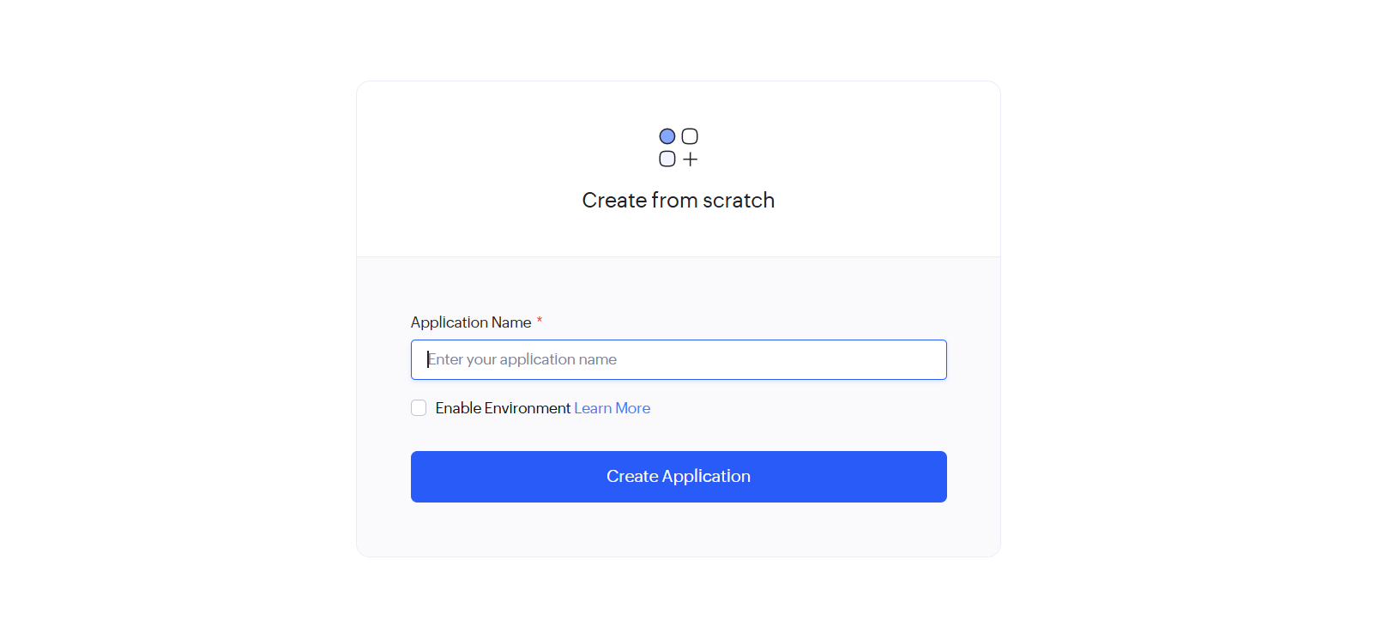
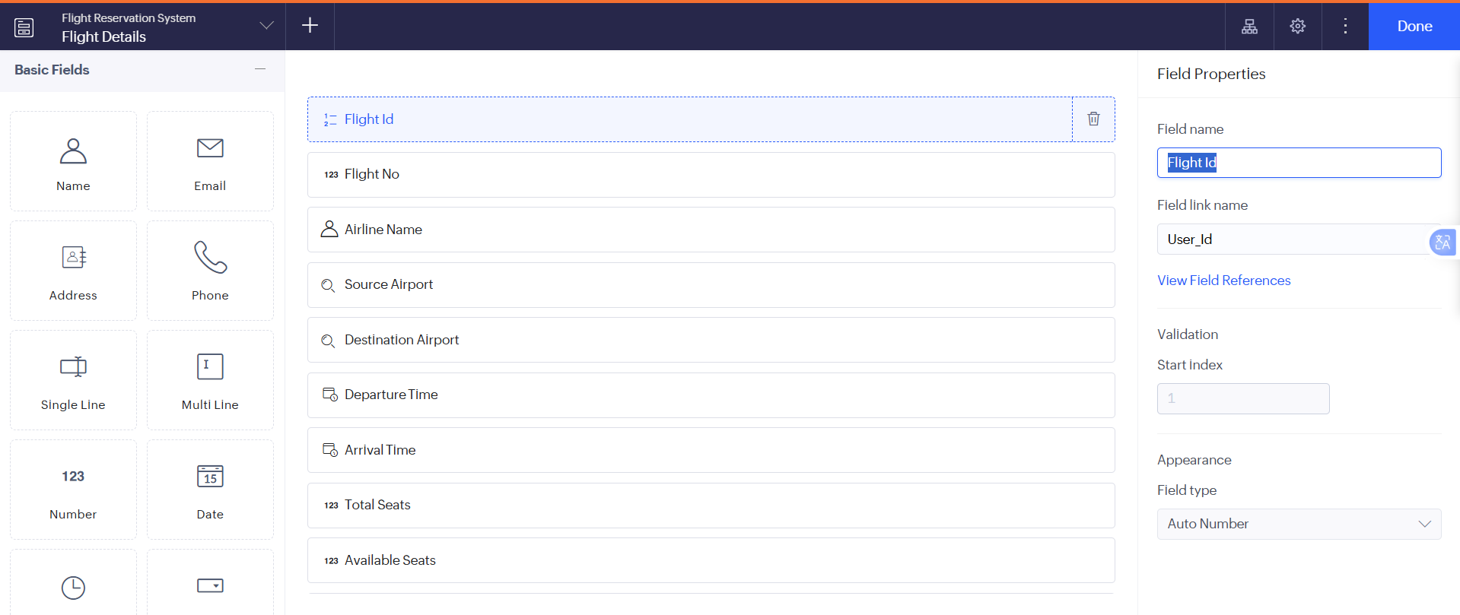

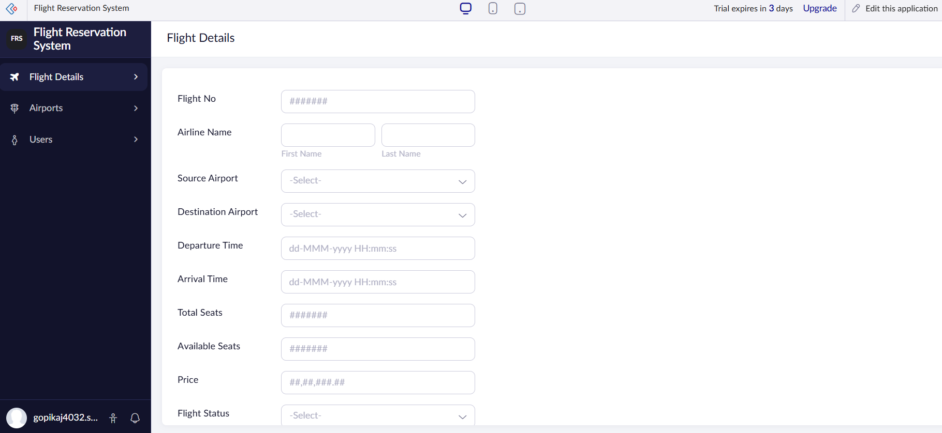

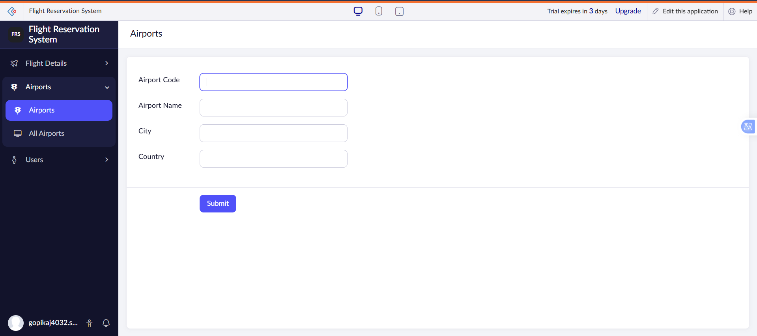
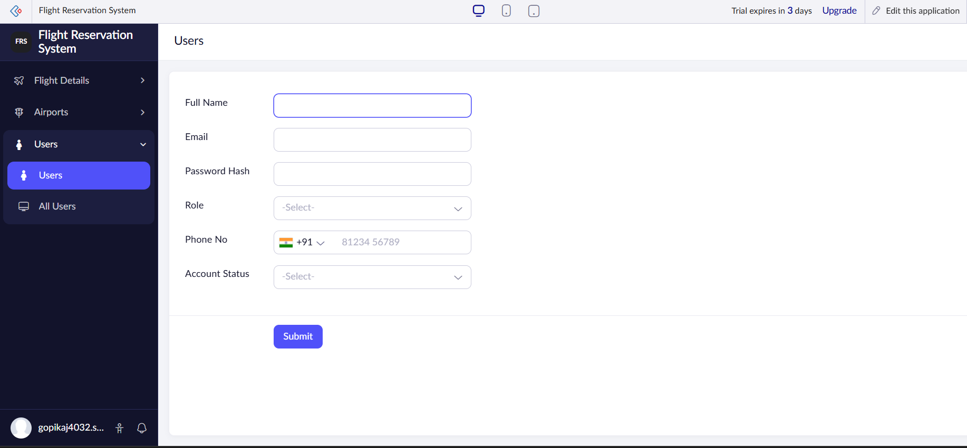

RESULT:
A cloud-based Flight Reservation System is successfully implemented as a SaaS application, enabling users to book and manage flight reservations online.

